

**Kernel Synchronization with Semaphores**

***Objective: In this lab you will fix a LKM called*** incrementer***. The LKM creates five threads which are not using any kernel synchronization to prevent race conditions. The goal of the lab is to log the start and completion of each thread using a global counter. However, without any concurrency mechanisms in place the LKM will fail to log properly.***

***Reference:*** LKI/Lab9

1. Use your newfound knowledge of semaphores to repair this LKM without the fear of concurrency problems.

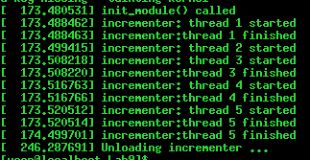

1. Use the following code sequence to get started with the LKM. 